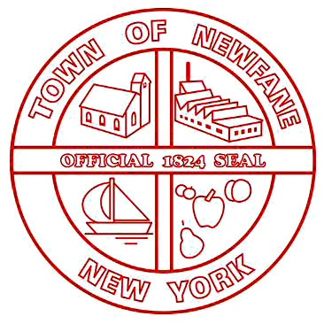
SUPERVISOR
716-778-8531

TOWN CLERK
716-778-8822
FAX 716-638-4183

ASSESSOR
716-778-8827

TAX COLLECTOR
716-778-6052

BUILDING INSPECTOR
716-778-5947

WATER/SEWER
716-778-8132

TOWN OF NEWFANE
2737 Main Street
Newfane, New York 14108

FAX 716-638-4261
JUSTICE COURT
2896 Transit Road
Newfane, New York 14108
716-778-9292

HIGHWAY
716-778-8844

WATER/SEWER
MAINTENANCE
716-778-8587

6176 McKee Street
Newfane, New York 14108

TDD 1-800-662-1220

RESOLUTION NO. 63 - 2023

RESOLUTION EMPOWERING THE TOWN OF NEWFANE PLANNING BOARD
TO WAIVE REQUIREMENTS IMPOSED BY LOCAL LAW NO. 1,
SHORT TERM RENTAL ESTABLISHMENTS,
PURSUANT TO TOWN LAW SECTION 274-b 5

WHEREAS, the Town of Newfane has passed a Local Law No. 1, establishing conditions and
requirements for the granting of a Special Exception Use for Short Term Rental Establishments, by
the Town of Newfane Planning Board,

WHEREAS, circumstances may arise in the consideration of each application, whereupon it may be necessary in the best interests of the health safety or general welfare of the community, to waive certain requirements set forth in said Local Law for the granting of such special exception use permit to an applicant, and

WHEREAS, Town Law Section 274-b5 permits the Town Board to empower the Town of Newfane Planning Board to waive certain requirements set forth in said Local Law for the granting of such special exception use permit, when it may be necessary in the best interests of the health, safety or general welfare of the community to do so,

and

NOW THEREFORE, BE IT RESOLVED THAT

The Town Board of the Town of Newfane does hereby empower the Town of Newfane Planning Board
to waive certain requirements set forth in said Local Law for the granting of such special exemption use permit, when it may be necessary in the best interests of the health, safety or general welfare of the community to do so.
DATED: _________________________________

John Syracuse, Supervisor _____________________________

Laura Rutland, Councilwoman _____________________________

Sue Neidlinger, Councilwoman _____________________________

Richard Coleman, Councilman _____________________________

Troy Barnes, Councilman _____________________________

DATED: December 29, 2023

CERTIFICATE OF CLERK

STATE OF NEW YORK
COUNTY OF NIAGARA
TOWN OF NEWFANE

______________________________
Mildred Kramp, RMC, CMC
SEAL Town Clerk Town of Newfane

